Homework 1

Ankit Chaudhary

ac957 [31470815]

> college = read.csv("/Users/ankitchaudhary/Documents/semester2_spring19/cs678_SMDS/week2/College.csv")

> fix(college)

Error in edit.data.frame(get(subx, envir = parent), title = subx, ...) :

X11 is not available

> rownames(college) = college[,1]

> college = college[,-1]

> summary(college)

Private Apps Accept Enroll Top10perc Top25perc F.Undergrad P.Undergrad Outstate

No :212 Min. : 81 Min. : 72 Min. : 35 Min. : 1.00 Min. : 9.0 Min. : 139 Min. : 1.0 Min. : 2340

Yes:565 1st Qu.: 776 1st Qu.: 604 1st Qu.: 242 1st Qu.:15.00 1st Qu.: 41.0 1st Qu.: 992 1st Qu.: 95.0 1st Qu.: 7320

Median : 1558 Median : 1110 Median : 434 Median :23.00 Median : 54.0 Median : 1707 Median : 353.0 Median : 9990

Mean : 3002 Mean : 2019 Mean : 780 Mean :27.56 Mean : 55.8 Mean : 3700 Mean : 855.3 Mean :10441

3rd Qu.: 3624 3rd Qu.: 2424 3rd Qu.: 902 3rd Qu.:35.00 3rd Qu.: 69.0 3rd Qu.: 4005 3rd Qu.: 967.0 3rd Qu.:12925

Max. :48094 Max. :26330 Max. :6392 Max. :96.00 Max. :100.0 Max. :31643 Max. :21836.0 Max. :21700

Room.Board Books Personal PhD Terminal S.F.Ratio perc.alumni Expend Grad.Rate

Min. :1780 Min. : 96.0 Min. : 250 Min. : 8.00 Min. : 24.0 Min. : 2.50 Min. : 0.00 Min. : 3186 Min. : 10.00

1st Qu.:3597 1st Qu.: 470.0 1st Qu.: 850 1st Qu.: 62.00 1st Qu.: 71.0 1st Qu.:11.50 1st Qu.:13.00 1st Qu.: 6751 1st Qu.: 53.00

Median :4200 Median : 500.0 Median :1200 Median : 75.00 Median : 82.0 Median :13.60 Median :21.00 Median : 8377 Median : 65.00

Mean :4358 Mean : 549.4 Mean :1341 Mean : 72.66 Mean : 79.7 Mean :14.09 Mean :22.74 Mean : 9660 Mean : 65.46

3rd Qu.:5050 3rd Qu.: 600.0 3rd Qu.:1700 3rd Qu.: 85.00 3rd Qu.: 92.0 3rd Qu.:16.50 3rd Qu.:31.00 3rd Qu.:10830 3rd Qu.: 78.00

Max. :8124 Max. :2340.0 Max. :6800 Max. :103.00 Max. :100.0 Max. :39.80 Max. :64.00 Max. :56233 Max. :118.00

> pairs(college[,1:10])

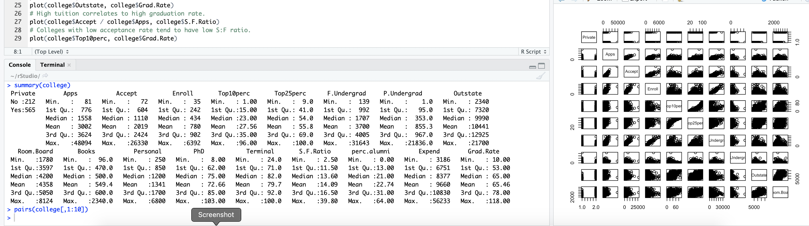

> plot(college$Private, college$Outstate)



> Elite = rep("No", nrow(college))

> Elite[college$Top10perc>50] = "Yes"

> Elite = as.factor(Elite)

> college = data.frame(college, Elite)

> summary(college$Elite)

No Yes

699 78

> plot(college$Elite, college$Outstate)



> par(mfrow=c(2,2))

> hist(college$Apps)

> hist(college$perc.alumni, col=2)

> hist(college$S.F.Ratio, col=3, breaks=10)

> hist(college$Expend, breaks=100)



> par(mfrow=c(1,1))

> plot(college$Outstate, college$Grad.Rate)

> # High tuition correlates to high graduation rate.



> plot(college$Accept / college$Apps, college$S.F.Ratio)

> # Colleges with low acceptance rate tend to have low S:F ratio.



> plot(college$Top10perc, college$Grad.Rate)

